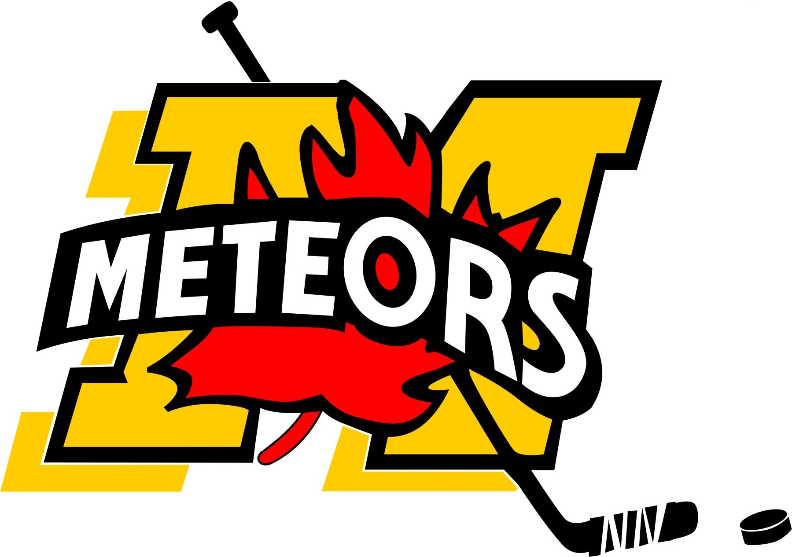  www.mitchellminorhockey.com | Mitchell Minor Hockey  Head Coach Application  2023 – 2024

Note: All information indicated within or attached to this application is strictly confidential

APPLICANT INFORMATION:

Name: _____________________________________

Address: ___________________________________Post Code: ________________

Phone: (Home) _________________________ (Work) ________________________

Email: _________________________________________

TEAM SELECTION: (Circle only one choice in Division and Level columns)

 | Division | Level
1st Choice: | U18 U15 U13 U11 U9 U8 | Boys B C LL Girls
2nd Choice: | U18 U15 U13 U11 U9 U8 | Boys B C LL Girls

If your choices are not available, would you consider a different team? Yes __ No__

COACHING HISTORY INFORMATION:

Year | Team | Association | Position

COACHING CERTIFICATES:

Level | Year Attended | Assigned Card #

POLICE CHECK: Yes _____ No _____
(Previous coaches – not required if one has been completed in the last 3 years)
(New coaches – one must be provided with application)

SUPPORT STAFF:

Name | Position | Previous Experience

MANDATORY INTERVIEW:

All applicants will be required to take part in an interview(s) with the Coaching Selection Committee. The time and location will be determined by the Committee. The applicant will complete the following questions attached (page 3) which will be the focus point of the interviews.

If accepted to a coaching position, I will:
- Upgrade my credentials as requested by Mitchell Minor Hockey (MMH).
- Attend coaches meetings on a regular basis.
- Comply with the MMH Constitution and OMHA/OWHA.

Signed: _____________________________________ Dated ________________

Thank you for expressing interest in coaching for Mitchell Minor Hockey (MMH)

Please return applications to csc@mitchellminorhockey.com. Please make sure Police Checks are completed with applications if they have not been done in past through Mitchell Minor Sports.
COACHING APPLICATION QUESTIONAIRE

Are you currently servicing a coaching suspension from previous year(s)?

Briefly list your playing/coaching hockey experiences which will assist you as a coach.

Explain in general terms you’re coaching philosophy.

Describe what you plan to teach your players? What anticipated team initiatives, objectives and goals you may have?

In your words, what do you think your role is as a coach?

What would be the projected roles of your coaching staff?

What is your attitude towards winning and losing?

